**HMDA Data Challenge**

1. **Data Munging**
2. **Merge Data**

**Code:**

# set a working directory

setwd('C:\\Users\\dalalshobhit\\Desktop\\CapitalOneData')

# Provide paths for loan data and institution data on your disk

loanDataPath <- "C:\\Users\\dalalshobhit\\Desktop\\CapitalOneData\\2012_to_2014_loans_data.csv"

institutionDataPath <- "C:\\Users\\dalalshobhit\\Desktop\\CapitalOneData\\2012_to_2014_institutions_data.csv"

mergedData <- merge(loanData, institutionData, by=c("Agency_Code","Respondent_ID", "As_of_Year"), all.x = TRUE)

1. **Provide a simple API of two functions:**

* **hmda_init()**

**Code:**

# hmda_init() implements a method to merge and get expanded data

hmda_init <- function() {

loanData <- read.csv(loanDataPath, header = TRUE)

institutionData <- read.csv(institutionDataPath, header = TRUE)

mergedData <- merge(loanData, institutionData, by=c("Agency_Code","Respondent_ID", "As_of_Year"), all.x = TRUE)

return(mergedData)

}

# call hmda_init() and create a data frame mergedExpandedData

mergedExpandedData <- hmda_init()

**Output:**

Execution of hmda_init() function

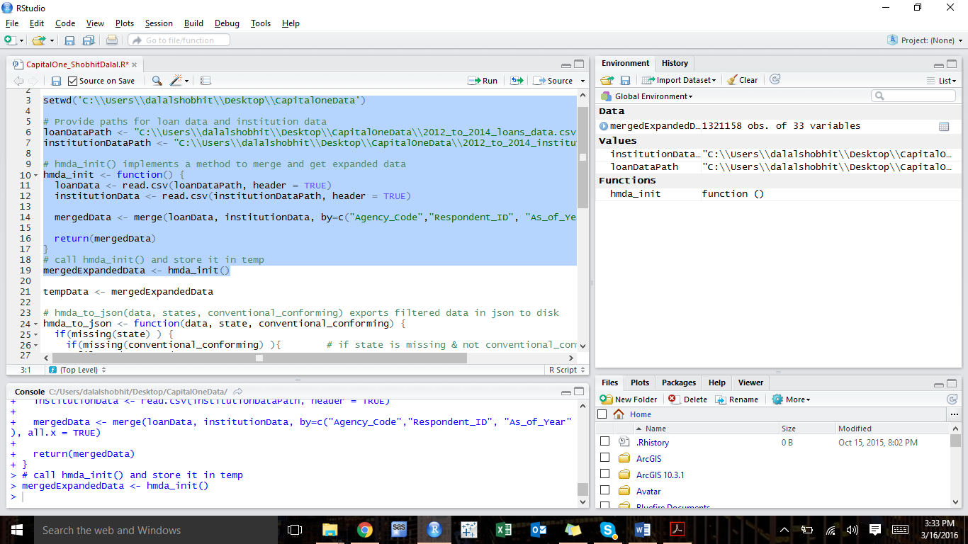

Observation:

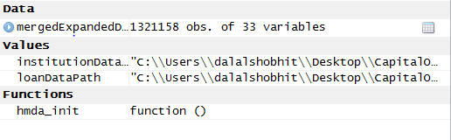

Merged Expanded Output:

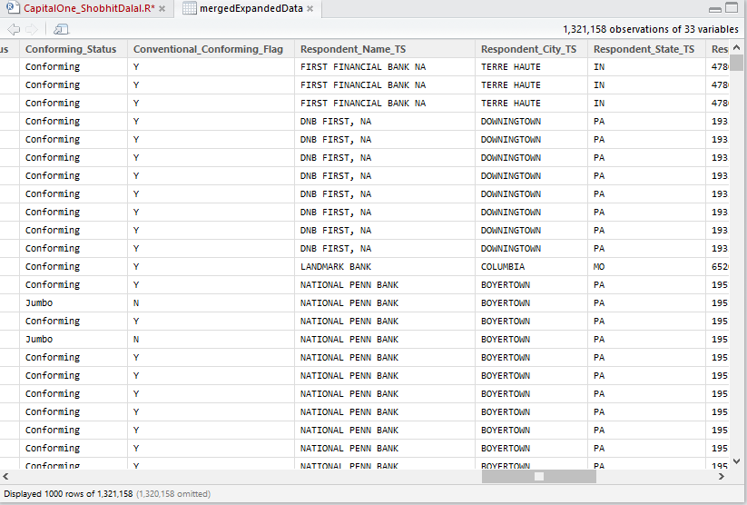

* **hmda_to_json(data, state, conventional_conforming)**

**Code:**

# install jsonlite package

install.packages(“jsonlite”, repos=<http://cran.r-project.org>)

# load jsonlite

library(jsonlite)

# hmda_to_json(data, states, conventional_conforming) exports filtered data in json to disk

hmda_to_json <- function(data, state, conventional_conforming) {

# if else loops for filtering data

if(missing(state) ) {

if(missing(conventional_conforming) ){

filteredData <- data

}

else { # if state is missing & conventional_conforming

filteredData <- subset(data, Conventional_Conforming_Flag == conventional_conforming)

}

}

else {

if(missing(conventional_conforming)) {

filteredData <- subset(data, State == state)

}

else { # if state is given & conventional_conforming

filteredData <- subset(data, State == state & Conventional_Conforming_Flag == conventional_conforming)

}

}

# Convert to JSON data

sink("jsonData.json")

cat(toJSON(filteredData))

sink()

# export the expanded dataset to disk

write.table(filteredData, "C:\\Users\\dalalshobhit\\Desktop\\CapitalOneData\\jsonData.json", sep=":")

return(filteredData)

}

# call hmda_to_json function and store it in showFilteredData (Give a path on your local machine where you want to write this file)

showFilteredData <- hmda_to_json(mergedExpandedData,"VA", “N”)

**Output:**

Execution of hmda_to_json() function:

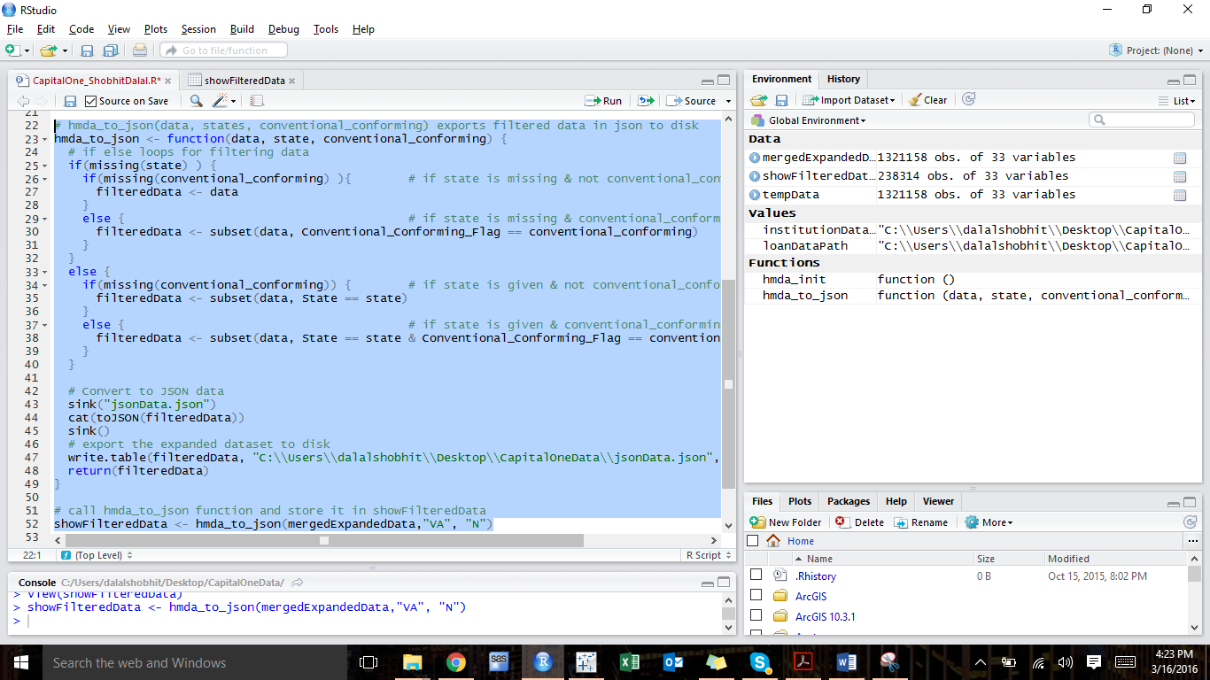

**Observation:**

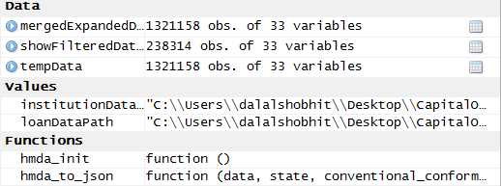

**Filtered Data Output:**

Both state(“VA”) and conventional_conforming(“N”) filters are applied

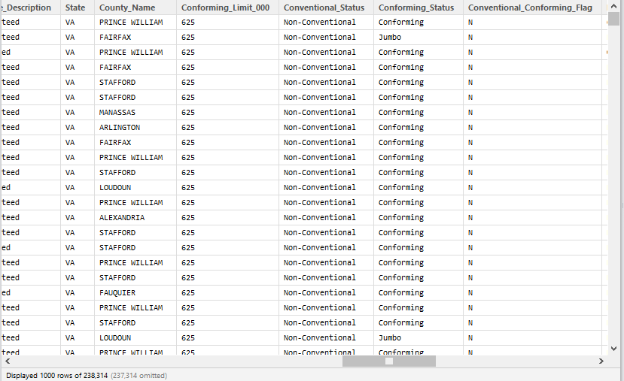

**Output of filtered & expanded JSON file on disk:**



**JSON data file:**

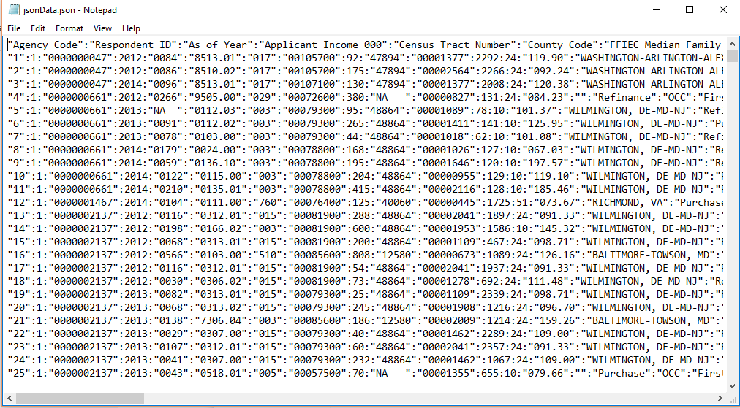

**Output for various test cases:**

* When both state & conventional_conforming filters are applied:

showFilteredData <- hmda_to_json(mergedExpandedData,"VA", “N”)

**Output:**

238,314 observations with state=”VA” and conventional_conforming=”N”

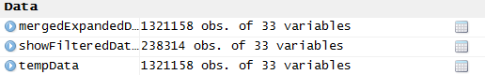

* When only state filter is applied:

showFilteredData <- hmda_to_json(mergedExpandedData,"VA")

**Output:**

679,703observations with state=”VA”

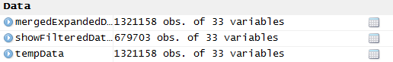

* When only conventional_conforming filter is applied:

showFilteredData <- hmda_to_json(mergedExpandedData, , “Y”)

**Output:**

882,206observations with conventional_conforming=”Y”

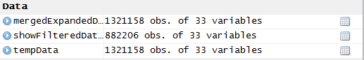

* When no filters are applied:

showFilteredData <- hmda_to_json(mergedExpandedData)

**Output:**

1,321,158observations with no filters applied

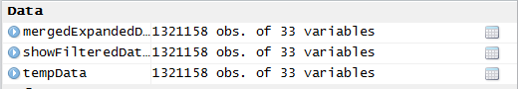

1. **Quality Check**
2. Apart from “Loan_Amount_000” and “Respondent_Name” two columns I think are most important to monitor are:

* **MSA_MD** – This data will be helpful to analyze the type of loans and amount of loans that are originated or purchased within a specific MSA or MD. It will be used to analyze which location will be more profitable, and where many loans are applied and originated.
* **Loan_Type_Description** – It states if a loan is conventional or non-conventional loan. Conventional loan indicates these are ideal applicants with good or excellent credit. Non-conventional loans can be FHA, FSA or VA loans and they are for low income borrowers or for borrowers with low credit scores. Based on the type of loan we can identify categories of people in a specific region and what kind of loans will be in more demand in that region.

1. **Quality assessment on ‘Loan_Amount_000’**

On analyzing ‘Loan_Amount_000’ data, it is noticed that there are entries with values of 5 digit values. To clean the data and make the entries uniform, a function cleaning_LoanAmount(data) is created.

This function will replace the 5 digit value by dividing it by 1000 to correctly represent them.

**Code:**

# Create a function cleaning_LoanAmount() for Quality Assssment of Loan_Amount_000

cleaning_LoanAmount <- function(clean_data) {

clean_data$Loan_Amount_000=as.numeric(as.character(clean_data$Loan_Amount_000))

class(clean_data$Loan_Amount_000)

# clean_data$Loan_Amount_000[ which(clean_data$Loan_Amount_000 < 999)]

clean_data$Loan_Amount_000[clean_data$Loan_Amount_000>999 & clean_data$Loan_Amount_000<99999] =

clean_data$Loan_Amount_000/1000

return(clean_data)

}

# Call cleaning_LoanAmount(data) function for Quality assessment of Loan_Amount_000

clean_data <- cleaning_LoanAmount(clean_data)

**Metadata:**

Loan_Amount_000: Enter value in thousands. For eg. 95,000 should be entered as 95

Applicant_Income_000: Enter value in thousands. For eg. 300,000 should be entered as 300

1. **Craft a visual data narrative**
2. **Market size by year & state**

* **Comparison of all types of loans grouped by year**

**Code:**

library(sqldf)

# Create SQL queries for each type of loan grouped by year

conventionalLoanSQL <- "SELECT As_of_Year,count(*) AS Conventional_Loans FROM mergedExpandedData WHERE Loan_Type_Description LIKE 'Conventional' GROUP BY As_of_Year"

VALoanSQL <- "SELECT As_of_Year,count(*) AS VA_Loans FROM mergedExpandedData WHERE Loan_Type_Description LIKE 'VA guaranteed' GROUP BY As_of_Year"

FSA_RHS_LoanSQL <- "SELECT As_of_Year,count(*) AS FSA_RHS_Loans FROM mergedExpandedData WHERE Loan_Type_Description LIKE 'FSA/RHS guaranteed' GROUP BY As_of_Year"

FHALoanSQL <- "SELECT As_of_Year,count(*) AS FHA_Loans FROM mergedExpandedData WHERE Loan_Type_Description LIKE 'FHA insured' GROUP BY As_of_Year"

# Create tables for each type of loans

conventionalLoans <- sqldf(conventionalLoanSQL)

VALoans <- sqldf(VALoanSQL)

FSA_RHSLoans <- sqldf(FSA_RHS_LoanSQL)

FHA_Loans <- sqldf(FHALoanSQL)

# Query to merge all tables

all_LoansSQL <- "SELECT c.As_of_Year, c.Conventional_Loans, v.VA_Loans, f.FSA_RHS_Loans, fh.FHA_Loans

FROM ((conventionalLoans c INNER JOIN VALoans v

ON c.As_of_Year = v.As_of_Year) INNER JOIN FSA_RHSLoans f

ON c.As_of_Year = f.As_of_Year) INNER JOIN FHA_Loans fh

ON c.As_of_Year = fh.As_of_Year"

allLoans <- sqldf(all_LoansSQL)

library(ggplot2)

library(reshape)

dfm <- melt(allLoans[,c('As_of_Year','Conventional_Loans','VA_Loans', 'FSA_RHS_Loans', 'FHA_Loans')],id.vars = 1)

# Bar plot each type of loans grouped by year

options(scipen=10000)

ggplot(dfm, aes(x=As_of_Year,y=value)) +

geom_bar(stat='identity', aes(fill=variable), position='dodge')

**Output:**

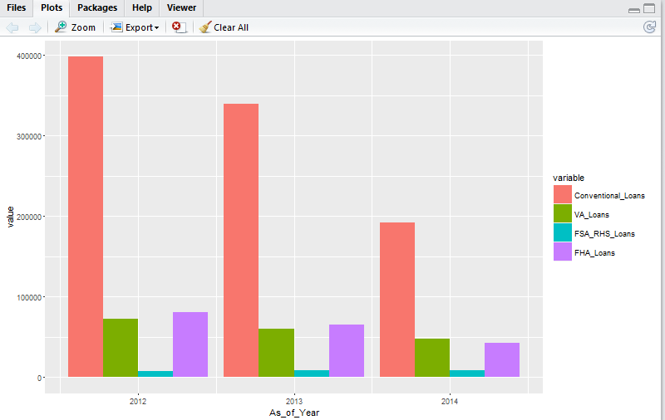

**Comparison of all types of loans grouped by year**

* **Percentage share of loans for each state**

**Code:**

# Pie chart of total loans grouped by State (no segregation of loans)

total_loansSQL <- "SELECT State, COUNT(*) AS Tot_loans FROM mergedExpandedData GROUP BY State"

total_loans <- sqldf(total_loansSQL)

Loan_Count <- as.vector(total_loans['Tot_loans'])

State <- as.vector(total_loans['State'])

pct <- round(Loan_Count/sum(Loan_Count)*100)

pct <- as.integer(unlist(pct))

State <- unlist(State)

lbls <- paste(State, pct) # add percents to labels

lbls <- paste(lbls,"%",sep="") # ad % to labels

pie(pct,labels = lbls, col=c("purple", "violetred1", "green3",

"cornsilk", "cyan", "white"))

**Output:**

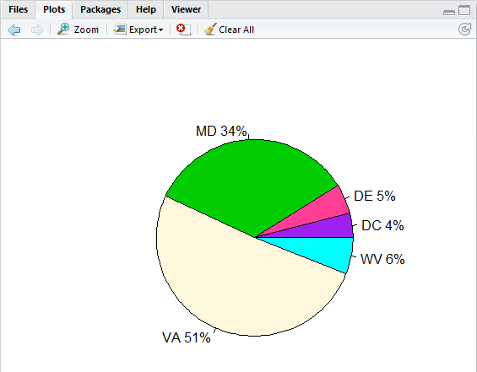

**Percentage share of loan application in 5 states**

* **Conventional conforming vs. non conventional conforming loans grouped by state**

**Code:**

# Create SQL queries for conventional_conforming loans vs. not conventional_conforming loans grouped by state

ConventionalConformingLoanSQL <- "SELECT State,count(*) AS ConventionalConforming_Loans FROM mergedExpandedData WHERE Conventional_Conforming_Flag LIKE 'Y' GROUP BY State"

ConventionalConformingLoans <- sqldf(ConventionalConformingLoanSQL)

NonConventionalConformingLoanSQL <- "SELECT State,count(*) AS NonConventionalConforming_Loans FROM mergedExpandedData WHERE Conventional_Conforming_Flag LIKE 'N' GROUP BY State"

NonConventionalConformingLoans <- sqldf(NonConventionalConformingLoanSQL)

totalLoansSQL <- "SELECT c.State, c.ConventionalConforming_Loans, n.NonConventionalConforming_Loans

FROM ConventionalConformingLoans c INNER JOIN NonConventionalConformingLoans n

ON c.State = n.State

ORDER BY 1"

totalLoans <- sqldf(totalLoansSQL)

totLoans <- melt(totalLoans[,c('State','ConventionalConforming_Loans','NonConventionalConformin g_Loans')],id.vars = 1)

# Bar plot each type of loans grouped by year

options(scipen=10000)

ggplot(totLoans, aes(x=State,y=value)) +

geom_bar(stat='identity', aes(fill=variable), position='dodge')

**Output:**

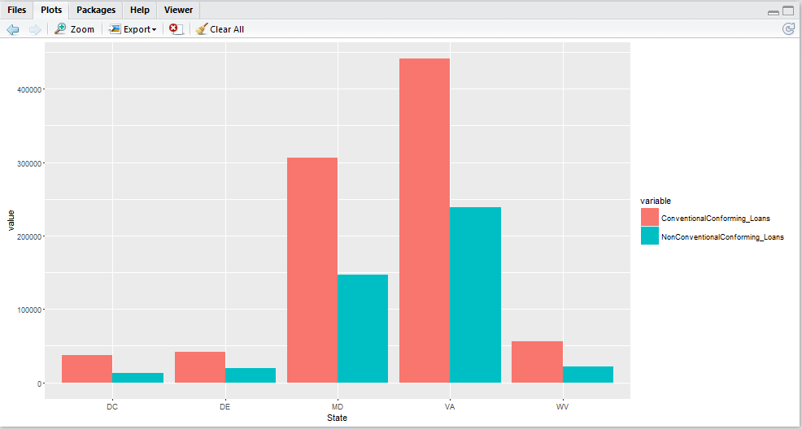

**Conventional_conforming vs. non_conventional_conforming loans grouped by state**

1. **Take it a step further!**

* **Clean Applicant_Income_000 for NA values**

**Code:**

# Create a function cleaningData() for Quality Assssment of Applicant_Income_000

cleaningData <- function(mergedExpandedData) {

mergedExpandedData$Applicant_Income_000[mergedExpandedData$Applicant_Incom e_000=='NA '] = '0'

mergedExpandedData$Applicant_Income_000=as.numeric(as.character(mergedExpand edData$Applicant_Income_000))

class(mergedExpandedData$Applicant_Income_000)

# Cleaning the data

meanIncome <- mean(mergedExpandedData$Applicant_Income_000)

mergedExpandedData$Applicant_Income_000[mergedExpandedData$Applicant_Incom e_000==0] = meanIncome

return(mergedExpandedData)

}

clean_data <- cleaningData(mergedExpandedData)

**Explanation:**

There are many rows with applicant income = “NA “.

‘cleaningData(data)’ function is created to treat this NA values. NA values are replaced with mean value of applicant income.

* **Average income of applicant grouped by State**

**Code:**

# Mean applicant income grouped by state

mean_income_state <- aggregate(clean_data$Applicant_Income_000,by=list(State=clean_data$State),mean,na. rm=TRUE)

ggplot(mean_income_state, aes(x=reorder(State,-x),y=x)) +

geom_bar(stat='identity', aes(fill=x)) +

labs(x="State", y="Avg. applicant income")

**Output:**

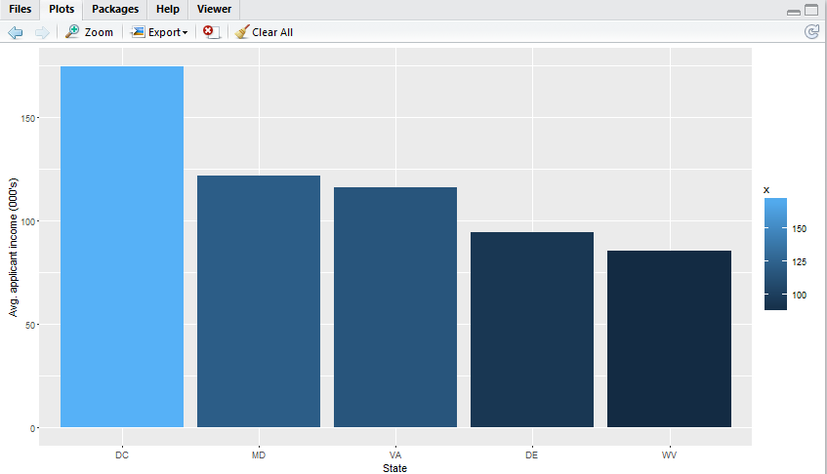

**Average applicant income by state**

**We can see that the average income of an applicant in DC is the highest while percentage share of loan applications is lowest in DC. But, Maryland and Virginia have 2nd and 3rd highest average income of an applicant respectively.**

**They also consists of a major share of loan applications of 51% & 34% respectively. Hence, we can say that from the results of visualizations of loan data of these states, we need to further analyze data of Virginia and Maryland to see if they can be a good place to expand with promising market.**

* **Relationship between no. of loan applications and Conforming Loan limit for a given County for Maryland**

**Code:**

# Create SQL queries for analyzing data for Maryland

Maryland_dataSQL <- "SELECT County_Name,count(*) AS no_of_loans,Conforming_Limit_000 FROM clean_data WHERE State LIKE 'MD' GROUP BY County_Name"

Maryland_data <- sqldf(Maryland_dataSQL)

Maryland_data <- Maryland_data[order(-Maryland_data$no_of_loans),]

**Output:**

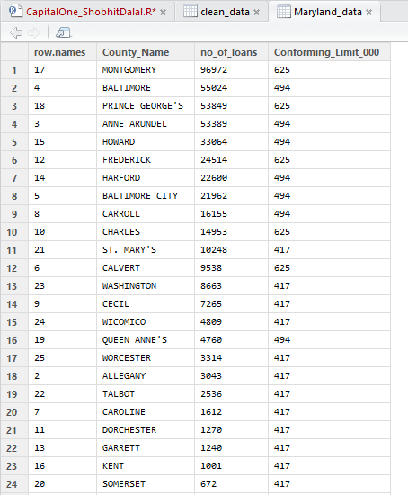

* **Relationship between no. of loan applications and Conforming Loan limit for a given County for Maryland**

**Code:**

# Create SQL queries for analyzing data for Virginia

Virginia_dataSQL <- "SELECT County_Name,count(*) AS no_of_loans,Conforming_Limit_000 FROM clean_data WHERE State LIKE 'VA' GROUP BY County_Name"

Virginia_data <- sqldf(Virginia_dataSQL)

Virginia_data <- Virginia_data[order(-Virginia_data$no_of_loans),]

**Output:**

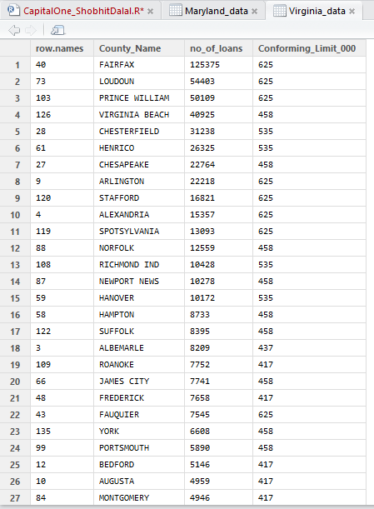

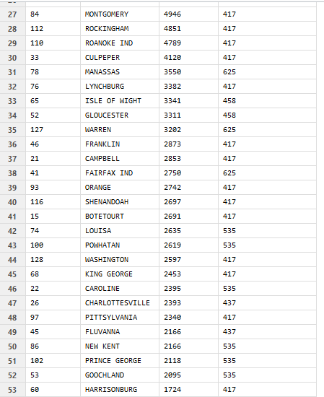

**Insights:**

**For both states Maryland and Virginia, we see that, as the single limit conforming loan limit for a given county decreases, number of loan applications also decreases.**

* **Average loan amount in various state (all loans)**

**Code:**

# Average loan amount grouped by state

mean_loanAmt_state <- aggregate(clean_data$Loan_Amount_000,by=list(State=clean_data$State),mean,

na.rm=TRUE)

mean_loanAmt_state <- mean_loanAmt_state[order(-mean_loanAmt_state$x),]

ggplot(mean_loanAmt_state, aes(x=reorder(State,-x),y=x)) +

geom_bar(stat='identity', aes(fill=x)) +

labs(x="State", y="Avg. loan amount (000's)")

**Output:**

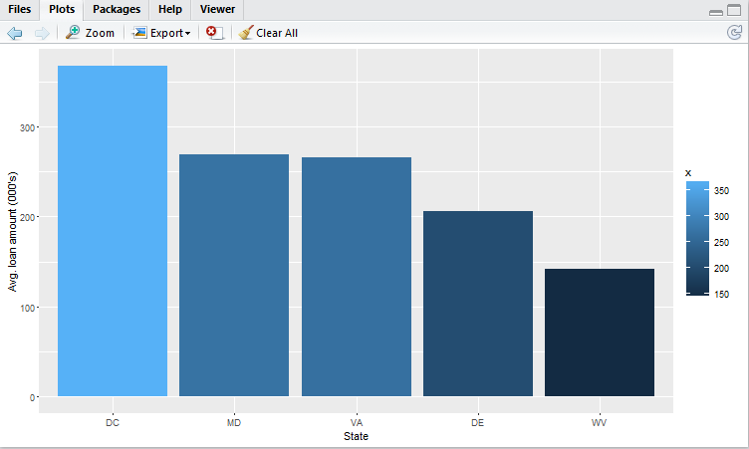

**Insights:**

**Maryland and Virginia have high average loan amount of 269.43 thousand and 265.31 thousand respectively. But, District of Columbia has the highest average loan amount of 368.16 thousand.**

**Recommendation:**

**Maryland and Virginia together consists of 85% of the total loan applications among five states. One of the reasons for such a large number of loan applications may be high average income of applicants. These two states have 2nd and 3rd highest average applicant income among five states. Thus, due to large number of loan applications and high income of applicants, Maryland and Virginia looks promising regions for home loans market. Change Financial should initially consider entering home loans market in these regions. As number of applications are more in counties with higher single unit conforming loan limit, they should first target counties with higher conforming limit for entering into a new market.**

**Also, Change Financial should further analyze the data of District of Columbia. DC have the highest average loan amount and highest average income of an applicant. Still, it has the lowest percentage share of loan applications among the five states.**